Asking and telling the way
- dialogues

* Write the dialogues!
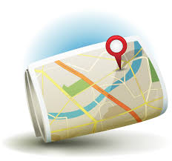
* Make two screenshots in google earth (one for each dialogue)!
* Insert them into your document!
* Mark the routes!
* Safe your dialogues!
* Send the document to your teacher!

a. A tourist is in front of the Cafe Fritz and wants to know the way to Filomena.

b. After shopping in the supermarket he wants to go to the Hotel Burg Vital in Oberlech.

