English 4
May 11th – 15th, 2020
Past Tense, Past Perfect Tense, Present Perfect Tense

Monday, May 11th, 2020

* revision “The Present Perfect Simple Tense”:

- Revise the Present Perfect Simple Tense!

Use your GRAMMAR – book
and the sheet “Present Perfect Simple (= Perfekt, Vergangenheit)” (p. 91)!

* worksheet “Fill in the Present Perfect Tense!” (p. 92)

* worksheet “Ask questions in the Present Perfect Simple with ...” (p. 100)

* negations in the Present Perfect Simple Tense:

- Write the NEGATIONS to the questions
(sheet, p. 100) into your ex – book!

Don’t write the keywords anymore or change them if possible!

e.g. 1. I have not been to England. (no keyword)
2. She has not come back yet. (changed keyword)

Tuesday, May 12th, 2020

video conference:

“Tenses revision”

11⁰⁰ o’clock
What you need: - ex – book
- grammar – book
- writing utensils

* worksheet “What are the tenses?” (p. 108)

* worksheet “What is the correct tense?” (p. 114):

- Do the exercises!
- Complete the register in
your ex – book!

Wednesday, May 13th, 2020

* worksheet “Form sentences and questions in the tenses in brackets” (p. 178):

- Write NEGATIONS into your ex – book!

* worksheet “Tenses – fill in the correct form of the verb” (p. 180)

Thursday, May 14th, 2020

* sheet “practice makes you perfect”: - Follow the instructions on
the sheet!

* SB, p. 77 / The Mag: - Watch the video on
www.digi4school.at! Send a
photo!
- Do the exercises!

* WB, p. 58 / Everyday English: - Do the exercise!

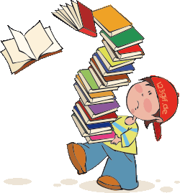
Friday, May 15th, 2020 – P.O. – BOX (8⁰⁰ – 10⁰⁰)

* Bring these things to the post-office box (P.O.B.):

- Workbook
- Student’s Book
- ex - book

