English 3 Corona exercises week 3: March 30th – April 3rd, 2020
Work individually for about 50min and always note down the date when you did the TASKS.
Let’s start!
TASK 1: Warm up Date:
Reading Comprehension
An important invention was our money – find out more about in your Topic März p. 38.
Open worksheet “Topic” and print it out. Stick it into your exercise book.
https://files.lehrerservice.at/pdf/to/to-mar20-englisch.pdf

Now Listen to the audio file and do the exercises:
https://files.lehrerservice.at/audio/jo/jo-mar20-englisch1.mp3
If you want to, you can do the online quiz (QR-Code in your magazine).
HW1: Take a picture of the worksheet and sent it to me: 0664 52 15 591

TASK 2: Listening Date:
Download the attached mp3 and the two worksheets (email) and print them out. Stick it into your exercise book. Listen and do the exercises.
HW2 Thursday April 2nd, 2020 Progress Check auf ezone – bitte so bald wie möglich erledigen, solange die ezone funktioniert

TASK 3: Lead in U9 Young people today Date:
STB 92-93/1-5 plus More! App
Read the “Learning Targets” in the green boxes at the top of page 92.
“To be allowed” gehört zum Thema „Modal verbs“ in unserem Grammar book. Lies bitte den entsprechenden Eintrag und „highlighte“ ihn, dann lies dir die Grammar box STB p.99 durch! (Fiona lies nur die Grammar box!)
Did you know the word Apartheid? If not google it before you start reading!
Now do exercises 1-5 and always READ INSTRUCTIONS CAREFULLY! Mark the words, you don’t now and sort out the meaning (dict.cc or wordlist in our Workbook). Nr. 5: Check the answers on digi4school and listen to the story.
Choose either Milase’s text or Curtis’ and practice reading aloud … record your voice with your mobile and listen to you reading
WB 67+68/ex 1 – 5 Read and Listen (on digi4school). You may also do the exercises on digi4school and not in your workbook!

TASK 4: Grammar Date:
WB 69/ex 6-9; write nr. 8 into your exercise book.
WB 70+71/11-14
HW3: Write 5 sentences what you are allowed to do in the Corona lock down and 5 sentences what you are not allowed to do. Send me an email or take a picture of the sentences and send a whatsapp.

TASK 4: Vocabulary Date:
STB 94/6 Sort out the meaning of these 6 words and study the words.
Now choose A (easy) or B (intermediate) in exercise 7.
Read the task of your choice (A or B) and now listen to Diego’s Story (ex. 7) on digi4school
Listen a second time if you want to and check and correct with a different colour.
What else do you know about the border between Mexcio and the US?
Note down here:

STB 96/10 Look at the picture dictionary and try so say the words that are in the picture without looking at words at the bottom! Then match pictures and words and check your answers.
STUDY the words for 1 minute (set a timer) and close your books.
Note down all the words you remember:

HW4: Wednesday:
- Fang an, die Wörter vom wordfile „Teen activites“ (WB p.74) auf 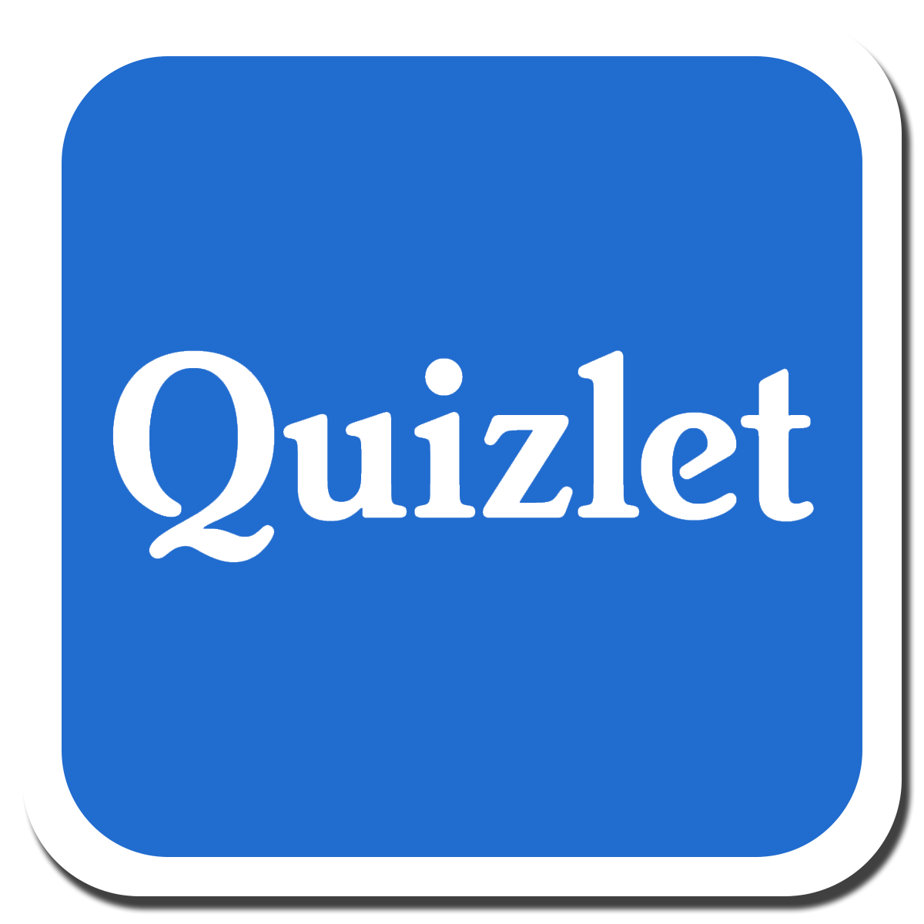 Nutzer imathies zu üben! Melde dich bitte in diesem Kurs an!! Das Kennwort lautet „corona“.

https://quizlet.com/join/KCdsK7Ygx

STB 97/11 Talking about permission (=Erlaubnis)
Read the dialogues – and answer my questions in whole sentences:
Are you allowed to have a tatoo now? I am ……………………………………………………………………………….
Will you be allowed to have on when you are older? ………………………………………………………..….
Was your mum or dad allowed to stay up late on school nights? She/He ………………………………..
Du siehst also, du kannst das „to be“ von to be allowed to in alle Zeiten setzen und somit auch über Zukunft und Vergangenheit sprechen!

Extra work (freiwillig): Call a friend or a parent and ask these questions below. Note down the answers and write a report (Zusammenfassung der Antworten). Put the extra work into your folder and you will get extra 5 “Mitabeitspunkte”.
When you ask a parent, you have to ask:
Were you allowed to… when you were 13?

TASK 6: Family Rules Date:

STB 98/13 Have a look at the mind map “Familiy rules”. Look at all bubbles and think about your family. What are the rules and what happens if you don’t follow the rules? Are you grounded sometimes (Hausarrest)?
HW5 Use the mind map to write a text about it. You can also use STB 99/14 as a help.
In your text make sure you make paragraphes (Einleitung / Hauptteil / Schluss)!
Email me this text as soon as possible.

Ferienarbeit Read an online book in your Easter holidays or get started now!
https://www.helbling.at/?pagename=homeschooling-at-englisch-sek
You can choose between “Holly the Eco Warrior” (20 points), “Robin Hood” (40 points) or “Dan in London”(30 points)
You can also download the audiofiles to each book and listen to some of the chapters.
Start with the “Before reading” activites to get an idea what your book is about.
Print out the “After reading activities” at the end of the book. Do them and put them into your “Übungsmappe”. You get the points for “participation” mark – so it counts more in the “cake”.

