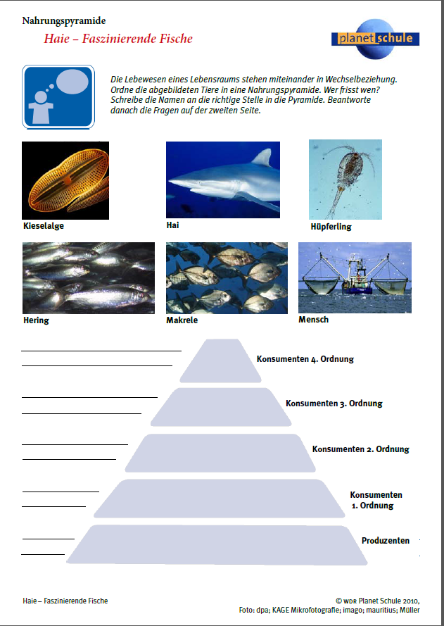

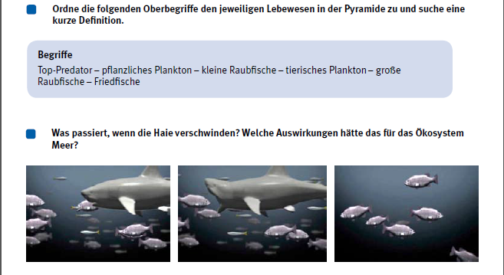

Beschreibe kurz in eigenen Worten, was im Film dazu erklärt wurde!

________________________________________________________________________________________________________________________________________________________________________________________________________________________________________________________________________________________________________________________________________________________________________________________________________________________________________________________________

