Revision Corona week 7 May 11th-15th, 2020

- Use the link or QR-Code to join our English class 3rd form and do the exercises.
https://learningapps.org/join/7ofmwipt
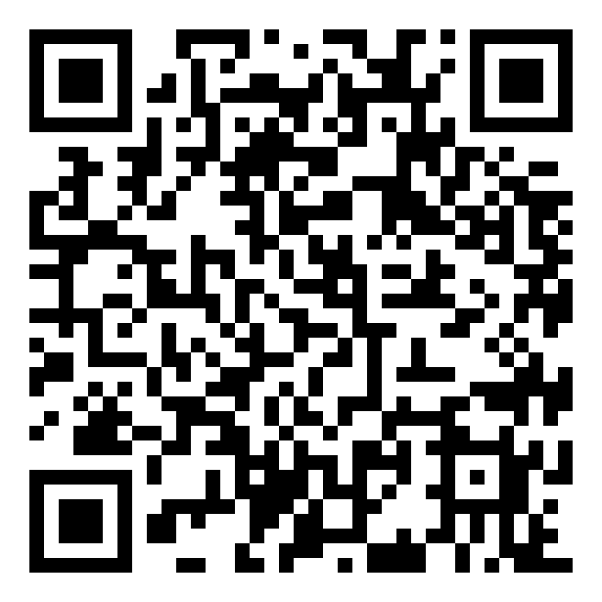
You need your mobile for the meeting!

2. Zoom Meeting on Tuesday
Be ready for a word battle U9-U10

3. Reading Comprehension
Read the interview with Lilly from “Crown Magazine” (click on the link):

“We’re all in this together!”
QUESTION: How is learning from home for you? (Read some of the comments from all over the world below the interview.) Are you looking forward to going back to school soon?
- Email me your story and if you want some photos.

Things for your
last “Postfach”
BASE CAMP: Finish your work plans: Unit 9 and 10 and at least 5 Grammar work sheets (Übungsmappe)

Heights bivouac: Finish the extra works of work plans U9+U10

Peak Performance: Project Malala + Worksheets/CHW and Revision “Corona week 7”

